Selected types of FBG apodization functions :

- gaussian function

- hamming function
- barthan function

- nuttall function
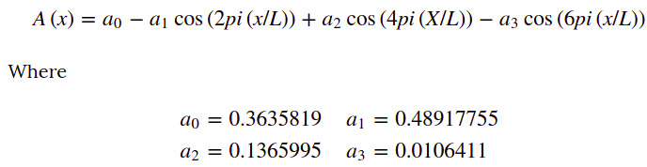
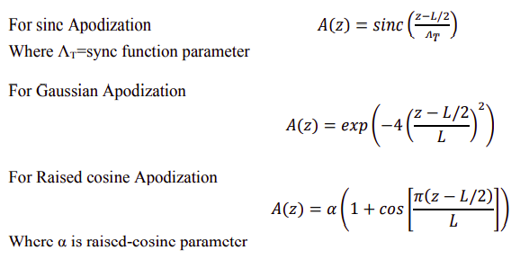

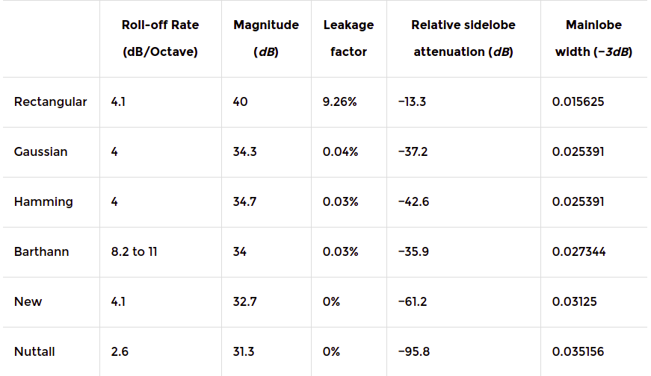
table shows comparision of different apodization functions in terms of roll-off rate, magnitude, leakage, relative sidelobe attenuation. Mainlobe width

